Design and implementation of multi-phase materials with interface effects using a level-set method

Project description and objectives :

Traditionally, materials design involves the ability to predict and tailor the properties and responses of a material for a given engineering application while controlling chemistry and processing history. Over the past few decades, materials design has expanded to take advantage of advanced optimization algorithms and methods [7]. In this approach, “spatial heterogeneity” is controlled such that combinations of materials or of material and space are arranged in configurations and with connectivities that offer enhanced performance [2-6]. Often the demands of anti-correlated property combinations (for example, high stiffness (Young’s modulus) and low expansion (coefficient of thermal expansion)) require the use of optimization tools to identify structures that may no longer be intuitive and involve complex shape [2-6].
The utilization of these mathematical modeling and computational approaches introduce idealizations and simplifications of the materials involved. While these idealizations are typically appropriate and warranted, sometimes features that are overlooked can provide significant design benefits. Recent advances in the development of the level set method for topology optimization have enhanced the treatment of material interfaces, a key feature introduced in multi-phase models that is nevertheless typically ignored. The interfaces of interest are those of dissimilar materials (bi-material) or heterophase boundaries within the classification of solid or bulk interfaces. For this class of interfaces, lattice-parameter changes in the interfacial region, induced by interfacial stresses, may have a pronounced effect on the physical properties and chemical composition at or near the interface. The present project seeks to capitalize on these potential property differences. In a variety of fields, material interfaces play a pivotal role in the performance of structures, often dictating tolerances and processing choices, lifetime and failure characteristics. Explicitly accounting for interfacial properties beyond a simple interpolation between bulk properties is necessary if one is to take full advantage of incorporating materials science input into optimal shape design methodologies.
Scope of the work
A collaboration between SIMAP and LJK (Grenoble, France), CMAP (Ecole Polytechnique, Palaiseau, France), and Lehigh University (Pennsylvania, USA) has been established in order to address the interdisciplinary problem of materials-based topology optimization. The team (R. Estevez, G. Parry, N. Vermaak, Y. Brechet, G. Michailidis, G. Allaire) has established level set-based optimization protocols that have already led to a joint publication [1]. However, improvements and augmentations of their algorithms and scope are needed in order to make a significant impact in the area of linear and nonlinear cellular materials design. The established codes are restricted to calculations in 2D and are written in the open source numerical computation software SCILAB, which prohibits for the moment, direct extension to 3D due to computational inefficiencies. The primary goals of the proposed work will then be to:

(i) Investigate interface effects in 2D benchmark problems of materials design. Optimize both the topology and materials interface profile for a prescribed set of 2D and 3D materials design problems that have been previously studied (without interface effects) in the literature. An example of a typical benchmark problem in materials design is given in Figure 1 [8]. The objective is to construct a microstructure with the specified homogenized elastic tensor, E*₁₁₁₁=E*₂₂₂₂=0.05 (GPa), and thermal stress tensor, a*₁₁=a*₂₂=0.1 (kPa/ C), under the volume ratio of 0.2 for the first phase (black) and of 0.24 for the second phase (grey, see Figure 1). The shear stiffness of the microstructure is constrained by E*₁₂₁₂ ≥ 0.05 (GPa) in order to ensure sufficient rigidity. This item investigates the influence of interface characteristics on improving the derivation of effective target properties of a heterogeneous representative (periodic) volume element. The proposed work for this task is an extension of the work performed with homogenization methods in which interfaces properties were ignored. Accounting for non-homogeneous interfaces between bulk materials can result in design improvements and opens new routes in manufacturing and processing for materials microstructures.

(ii) Extension to geometrically non-linear problems or problems with nonlinear material response. Optimization of materials design problems beyond benchmark cases will also be considered. These problems will incorporate more realistic boundary and loading conditions including: anisotropic bulk material properties, non-homogeneous thermal fields, distributed loads, and geometric and material non-linearity. Towards this goal, the selection and justification of appropriate optimization algorithms will also be addressed. In all cases, the influence of the interface zone thickness on the optimization will be explored.

(iii) Fabrication & Processing. Additive manufacturing presents an ideal technique for creating graded or diffuse interfaces in both polymeric and metallic systems. Both institutions involved in this project offer unique equipment and facilities to provide prototype realizations of topologically optimized systems. As mentioned above, it is our view that along with the advance of optimization tools, simultaneously, cooperative feedback with emerging processing and manufacturing methods is required to ensure integrated design optimization. Below, a few relevant complementary techniques available through the proposed partnership are described.

The project will also benefit from a close collaboration with the applied mathematics community: G Allaire at CMAP (Ecole Polytechnique, Paris) and F Jouve (Université Paris Diderot) and locally with E Bonnetier of laboratory LJK at Grenoble. The motivation is to pursue a fruitful long-term collaboration of this team initiated during N. Vermaak ‘s post-doc at SIMaP during 2012-2013.

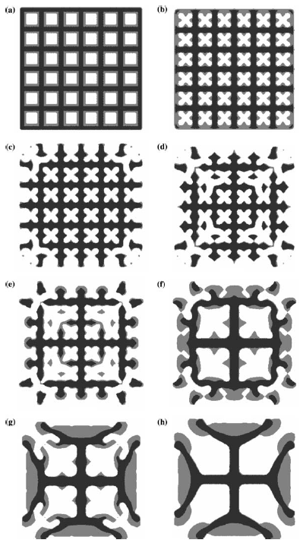

FIGURE 1: Optimal microstructure with low thermal expansion coefficients with a minimum shear stiffness and target material volume fractions specified. (a-g) show intermediate designs and (h) shows the final optimized design [10].

REFERENCES
[1] N. Vermaak, G. Michailidis, G. Parry , R. Estevez , G. Allaire, Y. Brechet, Material Interface Effects on the Topology Optimization of Multi-Phase Structures Using A Level Set Method, Structural and Multidisciplinary Optimization (Accepted, In press).
[2] N.A. Fleck, V.S. Deshpande, and M.F. Ashby, “Micro-architectured materials: past, present and future,” Proc. R. Soc. A 466, p. 2495-2516, 2010.
[3] M.F. Ashby and Y.J.M. Bréchet, “Designing hybrid materials,” Acta Mater. 51, p 5801-5821, 2003.
[4] Bouaziz, Bréchet, and Embury, "Heterogeneous and Architectured Materials: A Possible Strategy for Design of Structural Materials," Advanced Engineering Materials 10 no.1-2 (2008)
[5] H.J. Rathbun, D.D. Radford, Z. Xue, M.Y. He, J. Yang,V. Deshpande, N.A. Fleck, J.W. Hutchinson, F.W. Zok, A.G. Evans, “Performance of metallic honeycomb-core sandwich beams under shock loading,” International Journal of Solids and Structures 43 (2006) 1746–1763
[6] M.F. Ashby, “Multi-objective optimization in material design and selection,” Acta Materialia Volume 48, Issue 1, 1 January 2000, Pages 359–369
[7] M. Bendsoe, O. Sigmund, Topology Optimization. Theory, Methods, and Applications, Springer Verlag, New York, 2003.
[8] X. Wang , Y. Mei and M. Y. Wang, Level-set method for design of multi-phase elastic and thermoelastic materials, International Journal of Mechanics and Materials in Design (2004) 1:213–239

Application: candidates with a background in applied mathematics or mechanical engineering or materials science or applied physics are encouraged to apply. Candidates interested in experimental aspects should refrain. The topic is essentially numerical with some experimental aspects
Send resume and references to
Rafael.Estevez@simap.grenoble-inp.fr / ++33 ( 04 76 82 67 02

Directors : Rafael ESTEVEZ, G Parry (from Laboratory SIMAP at Grenoble) Natasha VERMAAK (Depart Mech Engng, Lehigh University, USA)

Duration: 36 months , starting in October 2014.
Location: University of Grenoble and Lehigh University

